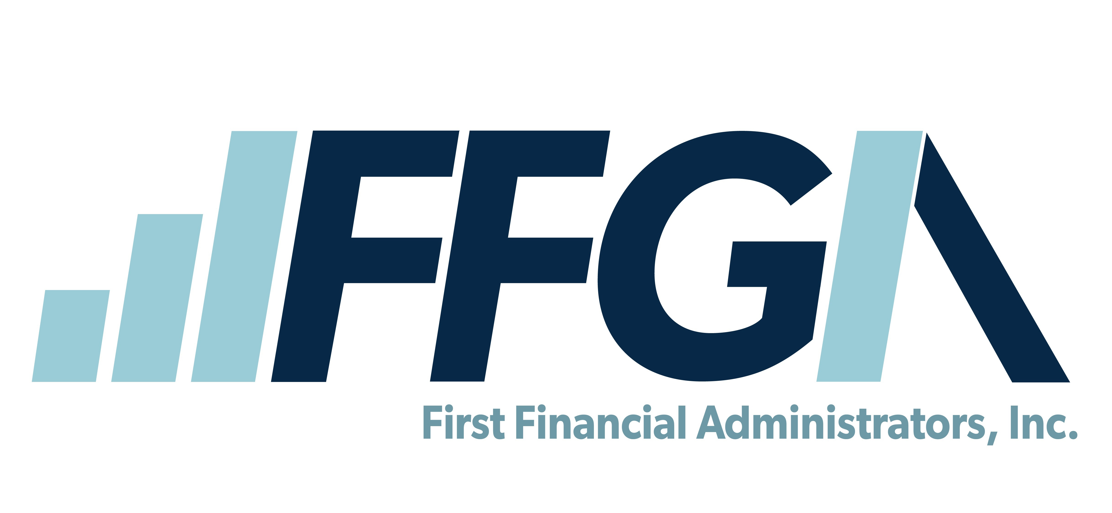

Medical Reimbursement Claim Form

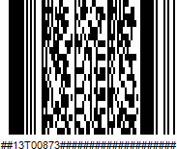
First Financial Administrators, Inc.

EMPLOYEE INFORMATION (Please Print)
EMPLOYER | FIRST NAME | MI | LAST NAME
ADDRESS | CITY | STATE | ZIP
PHONE  (Between Hours of 8am-5pm) | SSN | EMAIL ADDRESS
MEDICAL REIMBURSEMENT EXPENSE CLAIMS
 |  |  | SELECT ONE
DATE OF SERVICE | TYPE OF SERVICE (CO-PAY, RX, OTC, ORTHO, ETC.) | NAME OF PATIENT | REQUEST FOR  REIMBUR | USED BENEFIT CARD | AMOUNT OF EXPENSE
 |  |  |  |  | $
 |  |  |  |  | $
 |  |  |  |  | $
 |  |  |  |  | $
 |  |  |  |  | $
 |  |  |  |  | $
 |  |  |  |  | $
 |  |  |  |  | $
 |  |  |  |  | $
 |  |  |  |  | $
 |  |  | TOTAL AMOUNT REQUESTED |  | $

EMPLOYEE SIGNATURE (REQUIRED)
I certify that all expenses listed above are eligible for reimbursement under Section Code 213(d) and in accordance with my Plan and were incurred during a period while I was covered by my employers plan. These expenses have not and are not reimbursable under any other health plan.
The undersigned participant agrees that if the medical provider charges more than the insurance contractual amount and the discount is later refunded after the claim has been processed, these monies are owed back to the plan via personal payment or the provider may issue a credit back to the benefits card.
Note: If you have direct deposit, First Financial Administrators, Inc. will not pay bank charges for insufficient funds. Please contact your financial institution to verify deposit.

EMPLOYEE SIGNATURE: DATE:
CONTACT US TODAY:
PO Box 161968, Altamonte Springs, FL 32716| Online: www.ffga.com | Phone: 866-853-FLEX Fax number: 800-298-7785 | Tech Support: techsupport@ffga.com
Flex Receipts and Documents only: First_Financial_Receipts@Alegeus.com
F-MFSA-0324 | See page 2 for claim filing guidelines.

First Financial Administrators, Inc.
PO Box 161968, Altamonte Springs, FL 32716

Phone: 866-853-3539 · Fax: 800-298-7785

SUBMISSION GUIDELINES
Please follow these guidelines to ensure that your claims are reimbursed quickly. Failure to attach the proper documentation may result in claim denial.
Acceptable Documentation:
- Itemized receipt that shows the date of service, type of service received, provider name, patient name, amounts paid by the insurance, and amount owed.
- Explanation of Benefits (EOB) from insurance company
- Pharmacy receipt or statement that includes the RX number and name of the drug
- Detailed cash register receipt listing of all eligible over -the-counter items only

Unacceptable Documentation:
- Canceled checks
- Debit card or credit card receipts
- Balance forward or previous balance statements
- Paid on account statements
- Pre-payments for future services.
- Services incurred outside the plan year.

Orthodontia:
You must submit an orthodontic contract showing treatment start and end dates, the amount of the initial payment and the number of and amount of monthly payments.

Mail Claim Forms to:
First Financial Administrators, Inc. FSA Department
PO Box 161968
Altamonte Springs, FL 32716

Fax Claim Forms to:
800-298-7785

Email Claim Forms to:
First_Financial_Receipts@Alegeus.com

Fill out a claim form online:
www.ffga.com
Complete your claim form online and upload documentation on our secure participant portal by logging into www.ffga.com.

FFmobile Account App:
File a claim form on your mobile device using the FFmobile Account App. Available for download on the App Store or Google Play Store for Apple and Android devices.

Visit www.ffga.com for more information about Flexible Spending Accounts.

F-MFSA-0324

